LPIC Level One 考前須知(不含重點分析)
- 前言：
本文件目是為了提供準備參加LPIC-1考試學員而提供的說明文件，文件內容是依據LPI網站所公佈之考試目標與單項要求來製作，；本文件主要對象為已經參加過LPI課程之學員或曾負責管理Linux系統兩年以上之工作者；本文只提供重點分析以利各位做考前準備，關於許多實務操作技巧之細節並不在本文討論範圍之內。除非本文內容有謬誤，作者亦不提供任何回答。
- LPIC認證簡介：
LPI （Linux Professional Institute）是一家依據Linux標準基礎（LSB）的精神致力於標準化的、高水準的Linux認證的非營利性組織，並作為中立性質的Linux培訓和認證的主要提供商，專門負責界定中立於廠商和經銷商之認證標準。 它是由許多不同國家的志願者和專業人員组成的一個獨立運作的團體，透過郵件群組及其網站www.lpi.org來鼓勵大眾參與。目前LPI的各等級考試計劃是委託虛擬大學企業（VUE）與Thomson Prometric的測試中心在全球實施。LPI相信需要一個標準化的、多國性的、令人尊崇的考試來驗證個人在Linux上的技能等级。同時，這個考試也必須有利於公司作為聘雇Linux專業人才的標準。為了實現此一目的，LPI結合多方力量來設計一套完整的LPI認證考試。LPI透過全球的發展使之成為一個倍受公認和廣泛認可的Linux認證考試體系。如需進一步了解LPI和LPI考試，請訪問LPI網站：www.lpi.org。
- 報考須知：
各位在準備報名前，應確實準備好以下資料：
  - 正式的英文全名(最好是和護照上相同的，避免使用自行拼音或信用卡上的名字，可查詢http://www.pwcgi.com.tw/passport/)
  - 標準的英文地址(可上中華郵政查詢http://www.post.gov.tw/eaddress/eaddress.htm)
  - E-Mail
  - 信用卡資料
  - 確認考試科目
請注意要確認自己所欲報考的考試科目，通常考試科目皆有一個考試代碼+考試科目名稱．
例如：以LPIC來講，現在就提供五種類別考試科目：(最後更新：04/28/2003)
考試代碼 | 考試科目名稱 | 測考時間 | 考試費用 | 說明
117-101-DPKG | LPI Level 1 Exam 101 DPKG | 90 分鐘 | ＄US１００ | DPKG與RPM兩科  選擇一科(Level-1必考)
117-101-RPM | LPI Level 1 Exam 101 RPM | 90 分鐘 | ＄US１００ | DPKG與RPM兩科  選擇一科(Level-1必考)
117-102 | LPI Level 1 Exam 102 | 90 分鐘 | ＄US１００ | Level-1必考
117-201 | LPI 201 Advanced Linux | 90 分鐘 | ＄US１００ | Level-2必考
117-202 | LPI 202 Advanced Linux | 90 分鐘 | ＄US１００ | Level-2必考
- 可不依順序報考，但考生必須先取得Level-1資格才能正式取得Level-2資格＊

- 報考流程示範
- ：(以報考VUE考試中心為例)
- 連上http://www.vue.com
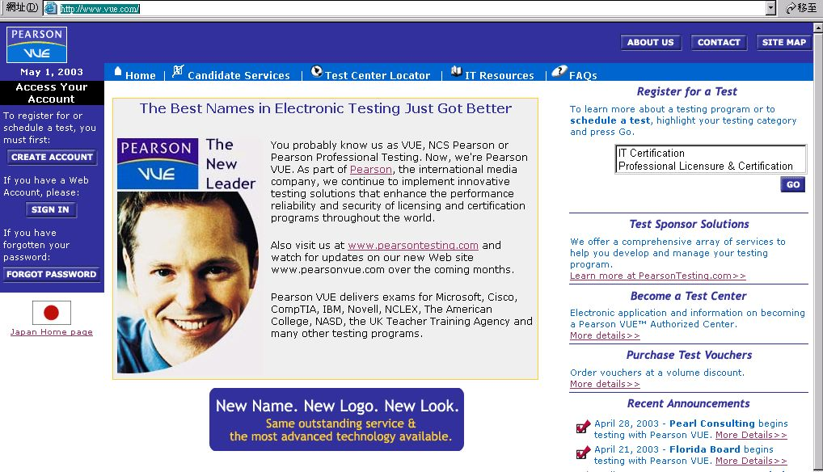

- 首次報考請由左方「CREATE ACCOUNT」按鈕進入
- 選擇類別：IT Certification
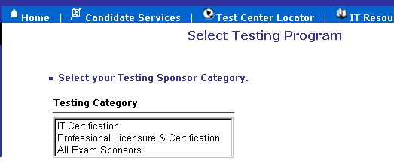
- 選擇認證種類：Linux Professional Institute Testing
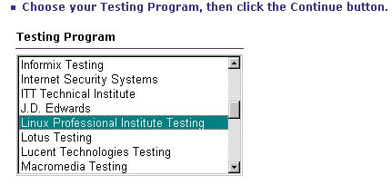
- 按下繼續
- 開始建立基本資料：
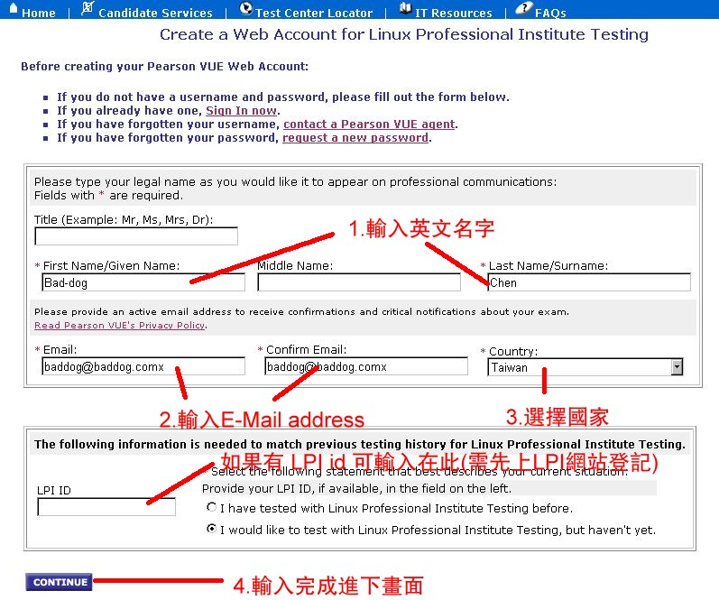

- 繼續建立個人聯絡資料：
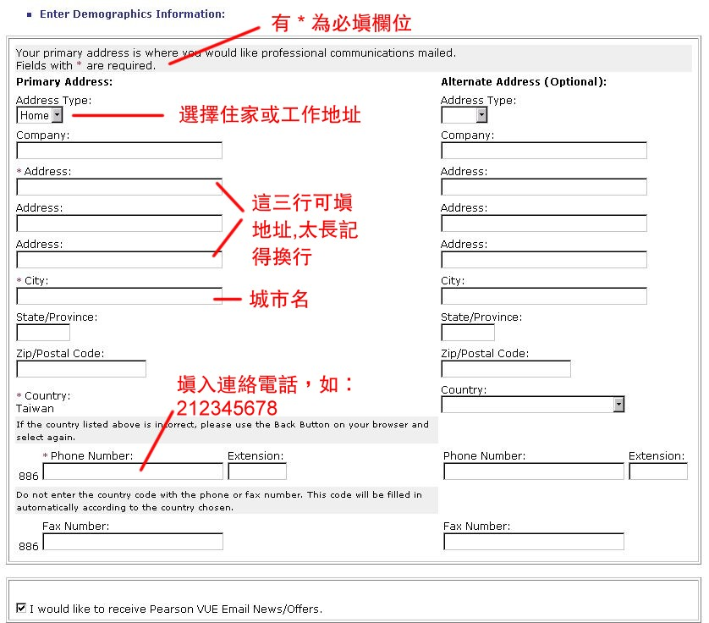
- 繼續設定考生帳號：
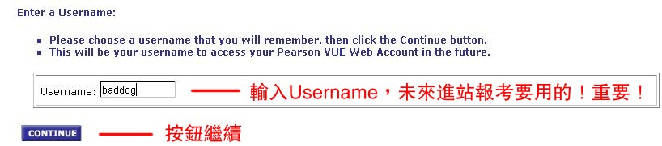
- 設定完成的確認畫面
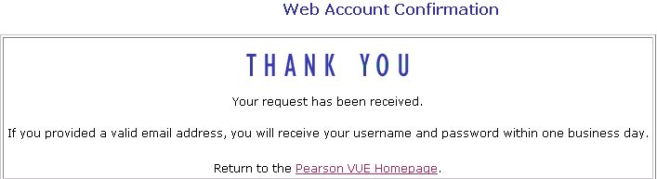
- 大約等一個工作天後就會收到VUE寄來的帳號與密碼確認信，記得要上網登入後更改密碼 !

- 上網變更密碼：
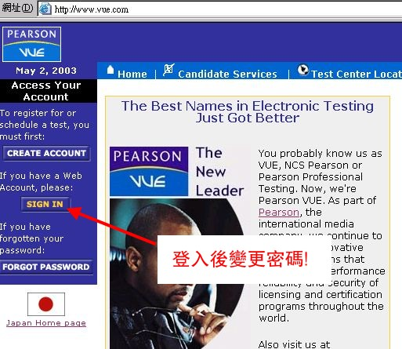
- 選擇認證種類：
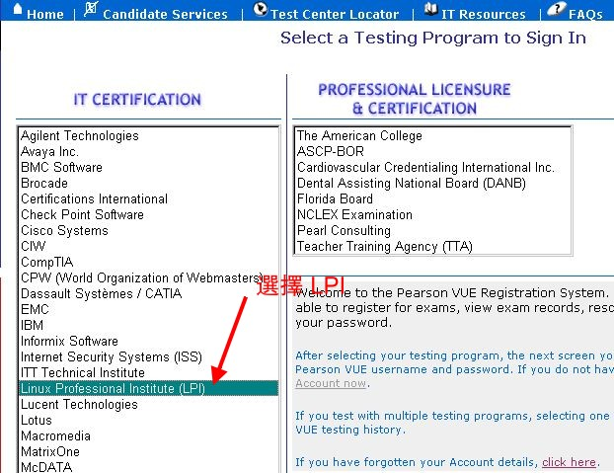

- 輸入帳號和密碼登入
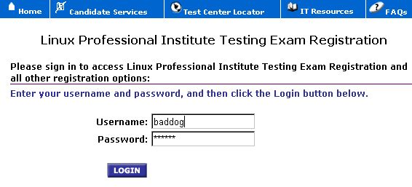
- 變更密碼
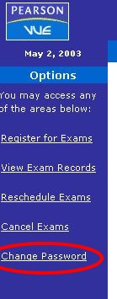
- 輸入新密碼
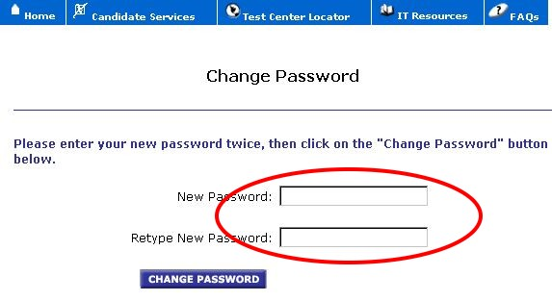
- 左選單說明
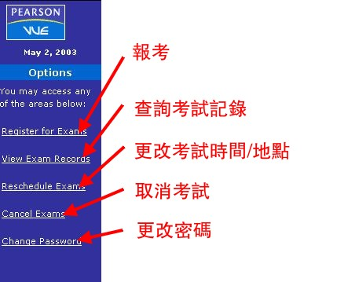
- 登入報考
- 選擇考試科目
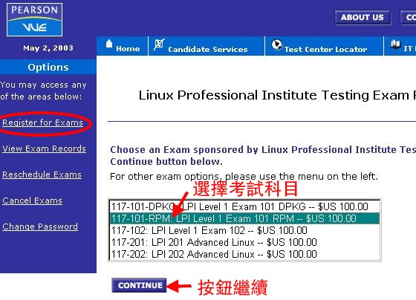
- 選擇語言
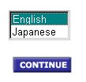
- 選擇考試中心
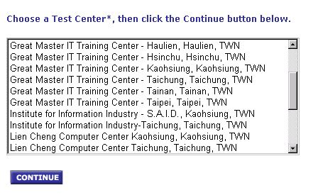
- 選擇時間區段
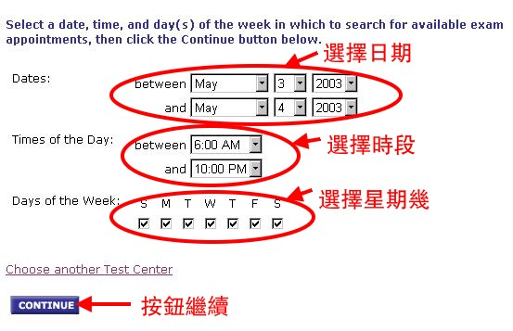
- 選擇考試時間
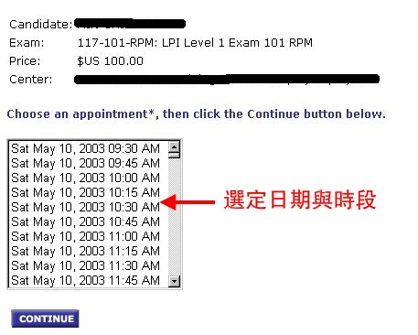
- 如有促銷劵或考試劵可輸入編號

- 輸入信用卡資料
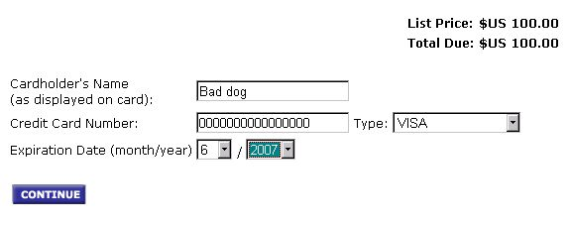
- 完成前最後確認
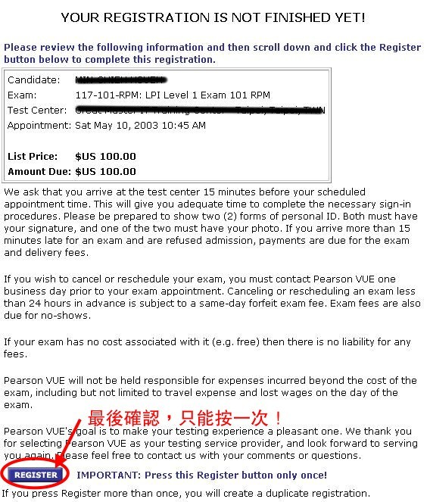
- 完成報考確認
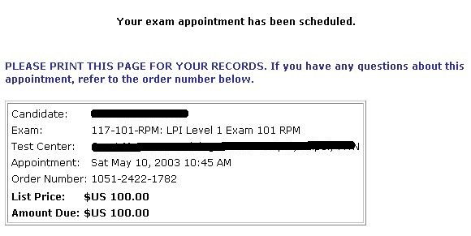

(Wgt.=Weights from 1=less importance to 8=most importance)
LPI 101 Exam - Objectives and Terms
Hardware and Architecture
Wgt. | Topic | Tested On
1 | Configure fundamental BIOS settings | /proc/ioports,/proc/interrupts,/proc/dma,  /proc/pci files
1 | Configure modem and sound cards | PPP, SLIP, etc.
1 | Set up SCSI devices | /proc/scsi/ and other SCSI parameters
3 | Set up different PC expansion cards | /proc and the utilities: pnpdump, isapnp and lspci  Key files:/proc/dma, /proc/interrupts  /proc/ioports, /proc/pci
1 | Configure communication devices | /proc and setserial
1 | Configure USB devices | lspci and usbmodules as well as assorted files
Linux Installation and Package Management
Wgt. | Topic | Tested On
5 | Design hard disk layout | Filesystem knowledge as well as swap space, mount points, and the Key files:/ (root) filesystem, /var filesystem  /home filesystem
1 | Install a boot manager | lilo,grub-install, the Master Boot Record, and superblock  /etc/lilo.conf, /boot/grub/grub.conf
5 | Make and install programs from source | gzip/gunzip, bzip2, tar, make, and configure
3 | Manage shared libraries | ldd and ldconfig /etc/ld.so.conf, LD_LIBRARY_PATH
8 | Use Debian package management | Unpack, confugre, dpkg, dselect, dpkg-reconfigure, apt-get, and alien
8 | Use Red Hat Package Manager (RPM) | rpm and related files:  /etc/rpmrc  /usr/lib/rpm/*
GNU & Unix Commands
Wgt. | Topic | Tested On
5 | Work on the Command Line | bash, echo, env, exec, export, man, pwd, set, and unset
6 | Process text streams using filters | cat, cut, expand, fmt, head, join, nl, od, paste, pr, sed, sort, split, tac, tail, tr, unexpand, uniq and wc
3 | Perform basic file management | cp, find, mkdir, mv, ls, rm, rmdir and touch
5 | Use streams, pipes, and redirects | tee and xargs as well as the slew of redirect characters
5 | Create, monitor, and kill processes | bg, fg, jobs, kill, nohup, ps and top
3 | Modify process execution priorities | Nice, ps, renice and top
3 | Search text files using regular expressions | grep, regexp, and sed
1 | Perform basic file editing operations using vi | Edit text, as well as copy, move, and delete it

Devices, Linux Filesystems, Filesystem Hierarchy Standard
Wgt. | Topic | Tested On
3 | Create partitions and filesystems | fdisk and mkfs
3 | Maintain the integrity of filesystems | debugfs, df, du, dumpe2fs, e2fsck, fsck, mke2fs and tune2fs
3 | Control mounting and unmounting filesystems | mount and umount, and /etc/fstab files
3 | Managing disk quota | edquota, quota, quotaon and repquota
5 | Use file permissions to control access to files | chattr, chmod, and umask
1 | Manage file ownership | chgrp, chmod, and chown
1 | Create and change hard and symbolic links | ln
5 | Find system files and place files in the correct location | find, locate, slocate, updatedb, whereis, and which
X
Wgt. | Topic | Tested On
5 | Install and configure Xfree86 | XF86Setup, xf86config and xvidtune /etc/X11/XF86Config  .Xresources
3 | Set up a display manager | /etc/inittab and the /ect/X11/ files : /etc/inittab  /etc/X11/xdm/*, /etc/X11/kdm/*, /etc/X11/gdm/*
5 | Install and customize a window manager environment | xhost and the environment files and variables:  .xinitrc  .Xdefaults  DISPLAY

LPI 102 Exam - Objectives and Terms
Kernel
Wgt. | Topic | Items Tested On
4 | Manage/Query kernel and kernel modules at runtime | depmod, insmod, lsmod, modinfo, modprobe, rmmod, and uname, as well as the associated files
3 | Reconfigure, build, and install a custom kernel and kernel modules | make, and all its options and variants:  make targets: config, menuconfig, xconfig, oldconfig, modules, install, modules_install, depmod
Boot, Initialization, Shutdown, and Runlevels
Wgt. | Topic | Tested On
3 | Boot the system | dmesg, LILO, and GRUB
3 | Change runlevels and shutdown or reboot system | shutdown, init and /etc/inittab
Printing
Wgt. | Topic | Tested On
1 | Manage printers and print queues | lpc, lpq, lpr, lprm and /etc/printcap
1 | Print files | lpq, lpr and mpage
1 | Install and configure local and remote printers | lpd as well as /etc/printcap and other files
Documentation
Wgt. | Topic | Tested On
4 | Use and manage local system documentation | apropros, man, and whatis  MANPATH
3 | Find Linux documentation on the Intenet | Know where to find needed information, or run a good chance of finding links to the needed information
1 | Notify users on system-related issues | /etc/issue, /etc/issue.net and /etc/motd
Shells, Scripting, Programming and Compiling
Wgt. | Topic | Tested On
5 | Customize and use the shell environment | env, export, function, set, unset and related files:  ~/.bash_profile  ~/.bash_login  ~/.profile  ~/.bashrc  ~/.bash_logout  ~/.inputrc
3 | Customize or write simple scripts | chmod, for, test, and while

Administrative Tasks
Wgt. | Topic | Tested On
4 | Manage users and group accounts and related system files | chage, gpasswd, groupadd, groupdel, groupmod, grpconv, grpunconv, passwd, pwconv, pwunconv, useradd, userdel, and usermod
3 | Tune the user environment and system environment variables | env, export, set and unset  /etc/profile  /etc/skel
3 | Configure and use system log files to meet administrative and security needs | logrotate and tail -f ,/etc/syslog.conf ,/var/log/*
4 | Automate systems administration tasks by scheduling jobs to run in the future | at, atq, atrm, crontab and associated files
3 | Maintain an effective data backup strategy | cpio, dd, dump, restore, and tar
4 | Maintain system time | date, hwclock, ntpd, ntpdate and associated files
Networking Fundamentals
Wgt. | Topic | Tested On
4 | Fundamentals of TCP/IP | dig, ftp, host, ping, telnet, traceroute, and whois
7 | TCP/IP configuration and troubleshooting | dhcpd, dhcpclient, host, hostname, ifconfig, netstat, ping, pump, route, tcpdump, and traceroute  /etc/HOSTNAME or /etc/hostname  /etc/hosts,/etc/networks,/etc/host.conf,/etc/resolv.conf  /etc/nsswitch.conf
3 | Configure Linux as a PPP client | ip-down, ip-up and wvdial as well as the key files
Networking Services
Wgt. | Topic | Tested On
4 | Configure and manage inetd, xinetd, and related services | Related files : /etc/inetd.conf, /etc/hosts.allow  /etc/hosts.deny, /etc/services ,/etc/xinetd.conf  /etc/xinetd.log
4 | Operate and perform basic configuration of sendmail | mailq, newaliases, and sendmail  Key files:/etc/sendmail.cf, /etc/aliases or /etc/mail/aliases  /etc/mail/*, ~/.forward
4 | Operate and perform basic configuration of Apache | apachectl and httpd
4 | Properly manage the NFS, smb, and nmb daemons | mount, umount, and Key files:/etc/exports  /etc/fstab, /etc/smb.conf
4 | Set up and configure basic DNS services | named and Key files:/etc/hosts, /etc/resolv.conf  /etc/nsswitch.conf, /etc/named.boot (v.4) or /etc/named.conf (v.8)
4 | Set up secure shell (OpenSSH) | sshd, ssh-keygen and Key files:/etc/hosts.allow  /etc/hosts.deny, /etc/nologin, /etc/ssh/sshd_config  /etc/ssh_known_hosts, /etc/sshrc
Security
Wgt. | Topic | Tested On
4 | Perform security administration tasks | find, ipchains, iptables, passwd, socket
3 | Set up host security | /etc files related to security
1 | Set up user level security | quota and usermod

編者:薛閔介 (LPIC [1/2], CCNA, MC[SE/SA/DBA])

- END -

